**MicroStrategy to Power BI Migration Hackathon**

**Problem Statement:**

Migrate the following MSTR Tutorial Project Dashboards to Power BI.

1. Category Sales and Profit Performance
2. Enterprise Performance Management Dashboard

**Data source (Tutorial file – MS Access DB):**

Path: C:\Program Files (x86)\MicroStrategy\Tutorial Reporting

File Name : - TUTORIAL_DATA_7200.mdb

**Dashboard Details:**

1. **Category Sales and Profit Performance:**

* Columns such as Category, Subcategory and Region – to be used as slicers
* Ability to show the KPIs such as Sales, Cost, Profit and Profit Margin % over Current Month, Last Month, Last Quarter and Last Year
* Formula for the metrics are as follows:

|  |  |  |
| --- | --- | --- |
| **Metric** | **Formula** | **Table** |
| Sales | sum(TOT_DOLLAR_SALES) | subcateg_mnth_ctr_sls |
| Cost | sum(TOT_COST) | subcateg_mnth_ctr_sls |
| Profit | sum(TOT_DOLLAR_SALES - TOT_COST) | subcateg_mnth_ctr_sls |
| Profit % | Profit/Sales | subcateg_mnth_ctr_sls |



* Full MSTR SQL Query for reference. The SQL covers list of all required tables.



* PDF Export (for reference):



Note: The PBI Report should be able to replicate similar PDF export.

* Screenshot (as given below) for reference:

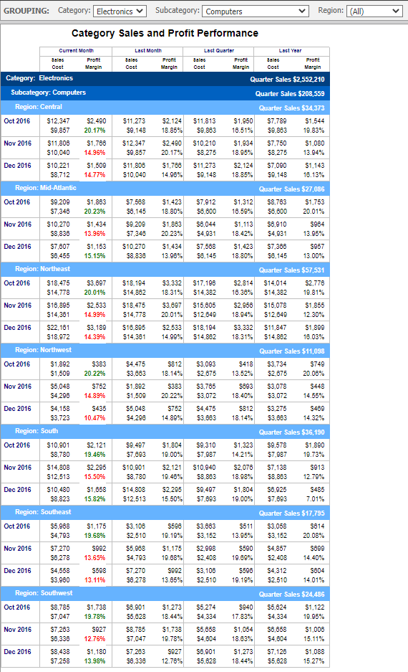

1. **Enterprise Performance Management Dashboard:**

* Replicate the charts and functionality to the extend as feasible in PBI as per the given mock-up/screenshot
* KPIs are calculated as below:

|  |  |  |
| --- | --- | --- |
| **Metric** | **Formula** | **Table** |
| Employee HeadCount | Count(Employee) |  |
| Revenue | sum(TOT_DOLLAR_SALES) | subcateg_mnth_ctr_sls |
| Cost | sum(TOT_COST) | subcateg_mnth_ctr_sls |
| Profit | sum(TOT_DOLLAR_SALES - TOT_COST) | subcateg_mnth_ctr_sls |
| Profit Margin | Profit/Revenue | subcateg_mnth_ctr_sls |
| Revenue per Employee | Revenue/Employee HeadCount |  |
| Revenue Forecast Percentage | Mod(Revenue,19)/ 100 |  |
| Revenue Rand Metric | Mod(Round(Randbetween(0,Revenue)),2) |  |
| Revenue Forecast Factor | Case(Revenue Rand Metric=0,(0.95+ Revenue Forecast Percentage),(0.95- Revenue Forecast Percentage)) |  |
| Revenue Forecast | Revenue * Revenue Forecast Factor |  |

* Screenshot (as given below) for reference:

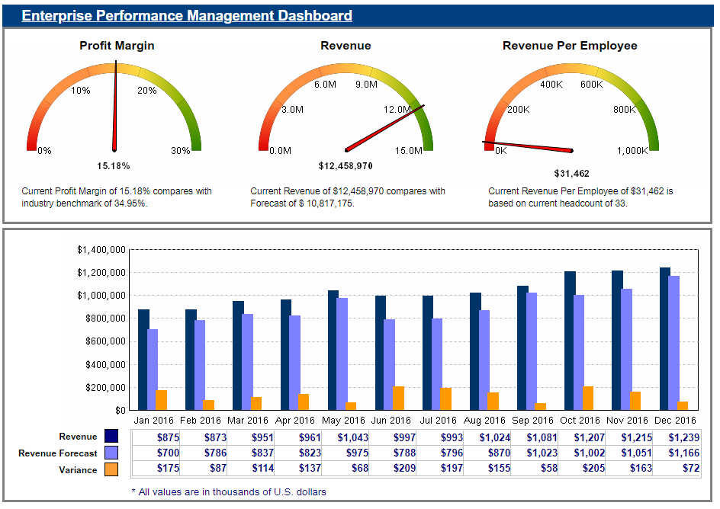

* SQL Query



* All metric definitions (for reference)

Employee headcount:

Revenue:

Revenue per Employee:

Revenue Forecast Percentage:

(Smart Metric NOT enabled)

Revenue Rand Metric:

(Smart Metric NOT enabled)

Revenue Forecast Factor:

(Smart Metric NOT enabled)

Revenue Forecast:

